Octagon ERP System

www.octagonerp.com

**Octagon ERP Modules:**

* **Accounts & Finance**
* **Admin**
* **Human Resource**
* **Inventory Management**
* **Plant Management**
* **Production Management**
* **Project Management**
* **Purchase Management**
* **Quality Management**
* **Sales and Distribution**
* **Super Admin**

**Implementation**

**Time**

**Work**

**Planning**

**Resource**

**Support**



**ATA Infotech Ventures Pvt Ltd**

***Project:* Cloud based Octagon ERP**

Version *2.0*

*14/03/2020*

Table of Contents

1 Introduction 4

1.1 Features 4

2 Purchase Management 5

2.1 Purchase Master Section:- 5

2.2 Purchase Process: 6

3 Store & warehouse management 7

3.1.1 Transaction: 7

4 Sales and Distribution 8

4.1 Master Data Management 8

4.2 Order Management Processing 8

5 Human Resource Management 9

5.1 Employee Self Services. (Employee Portal) 10

5.2 Payroll Management 10

5.2.1 HR Dashboard 11

5.2.2 Leave Management 12

5.2.3 Attendance Management 12

5.2.4 Loan Management 13

5.2.5 Income Tax Management 13

5.2.6 MIS Reports 13

5.2.7 HR Report Section 14

5.2.8 Leave & Attendance Report 14

5.2.9 Loan Module Reports 14

5.2.10 Salary Reports 14

5.2.11 Income Tax Related Reports 15

5.2.12 Statutory Report 15

6 Financial Accounting 16

7 Admin Management 20

7.1 User Management 20

8 Technology 21

# Introduction

Octagon-ERP offers solution that enables manufacturers to compete in the prevailing market atmosphere. Octagon-ERP Manufacturing has the capacity of both finite and infinite planning capabilities which assist you to develop original schedule. Octagon-ERP Manufacturing Management also transforms the supply chain to achieve production plan with your sales plan, manufacturing, finance and customers.

## Features

* **Fully Integrated**: within integrated web-based business management software, Octagon ERP provides a real-time holistic view of your business. From Order Management to Delivery Planning, from Inventory to Manufacturing, and from Project Planning to Execution – Octagon ERP is the answer to all your business needs.
* **Fully Compliant**: Stay up-to-date with your compliance obligations, and reconcile your accounts while looking forward to a hassle free filing of tax with Octagon ERP.
* **Automation**
* **Data Analysis**
* **Reporting**
* **Accounting**
* **Tracking and Visibility**
* **Quick to Deploy**: With Octagon ERP, implementations are both faster and less expensive than traditional business applications. Octagon ERP enables phased implementations according to your company’s need.

# Purchase Management

The ERP Purchasing Module provides complete purchasing control to generate and track purchase orders from PO issue to receipts including Vendor management. The Purchasing module provides controls for the complete procurement process, from vendor quoting through receiving, inspection, and cost accrual and vendor payment.

Vendor quotes are collected against items with multiple vendor price comparisons used by the system to recommend vendor selection for each purchase order. Requisitions can be generated automatically from BOM. or can be entered by users. Once approved, requisitions can be automatically converted to Purchase Orders. An item may be received directly to a line stocking location, to a specific job, or simply to its primary stocking location. We are categorized the module into Master, transaction and reports like

**Objectives of Purchasing:**

The classical definition of objectives of purchasing is to buy materials and services of the right quality, in the right quantity, at the right place, from the right source and at the right time.

However, in general management parlance the objectives of purchasing are:

* 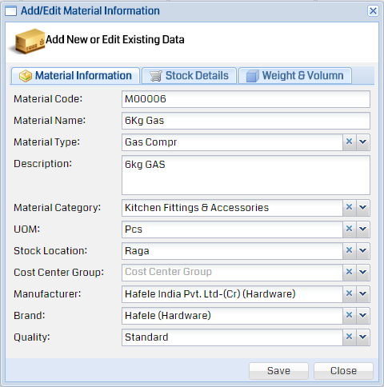To support company operations with an uninterrupted flow of materials and services.
* To buy competitively and wisely
* To help keep a minimum Inventory
* To develop reliable alternate sources of supply
* To develop good vendor relationship and a good continuing supplier relationship
* To achieve maximum integration with the other departments of the firm
* To train and develop highly competent personnel
* who are motivated to make the firm as well as their department succeed
* To develop policies and procedures which permit accomplishment of the preceding seven objectives at the lowest reasonable operating cost

## Purchase Master Section:-

* Material Information
* Material Master
* Vendor Registration
* Vendor - Material - Rate Master
* Freight Information
* Brand Information
* Material Quality
* Manufacturer Information
* Material Category
* 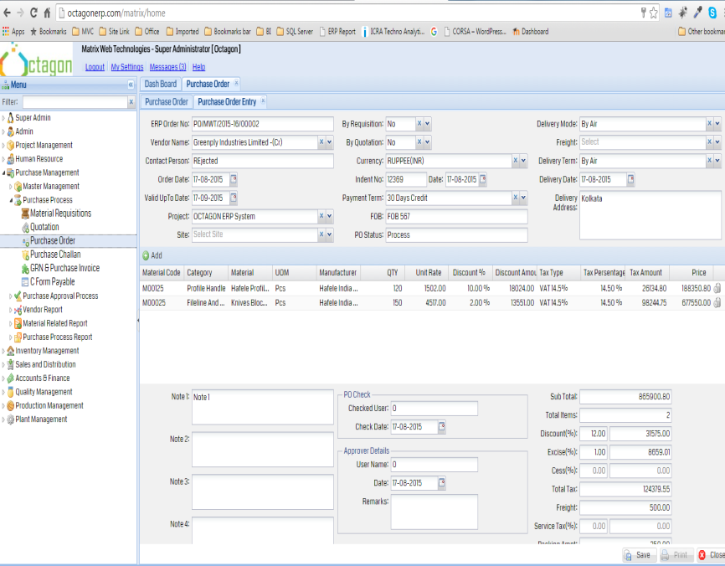Unit of Measurement
* Material Type
* Supplier Type Master
* Material Group
* Stock Group

## Purchase Process:

* Material Requisitions
* Quotation
* Purchase Order
* Purchase Challan
* GRN & Purchase Invoice
* C Form Payable

# Store & warehouse management

Store & warehouse management within the Octagon- ERP system provides a high degree of flexibility for handling complex storage needs, and assures continuous update of warehouse inventory through multiple inventory methods and different types of auditing. All materials input and output transactions are fully automated due to the seamless integration with other associated modules within the system. This also enables efficient, prompt and trouble-free inventory transactions within enterprises.

### Transaction:

* FG-Physical Stock Verification
* Material Issued by Requisition
* Material Requisition
* Material Issue / Stock Transfer
* Inter Stock Group Transfer

# Sales and Distribution

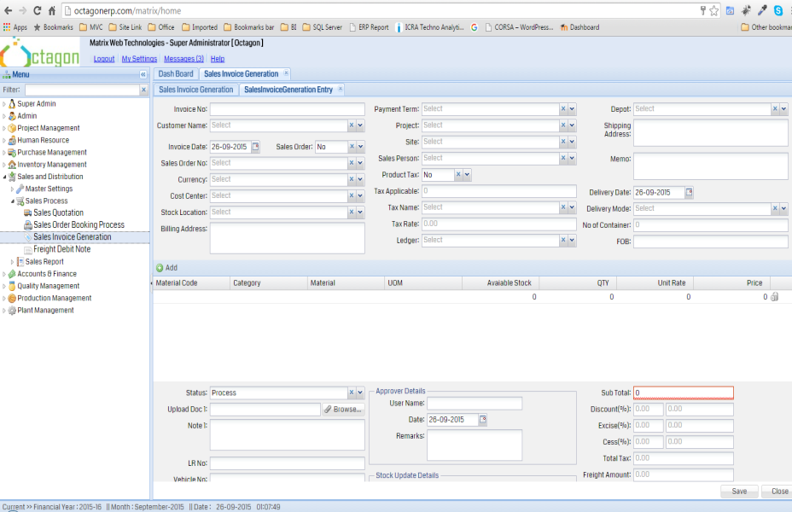ERP for Sales and Distribution helps organizations to manage the complete sales cycle from pre-sales to invoicing. It automates most commonly used functions of sales like Sales Force Automation (SFA), Product and Price Management, Order Management (from scheduling to delivering), Enquiry Management, Quotation Management, etc. ERP for Distribution is an excellent choice for enterprises having an extensive sales and distribution network to automate their business processes and ramp up their productivity quickly.

With ERP software for Sales and Distribution you can make your sales process more efficient by improving delivery timings, minimizing wastages and integrating sales information with other modules.

## Master Data Management

* Customer Group (like Commercial, Government, Individual, Internal, Interstate, Non Profit)
* Manage customer information with contact details, discount information, etc.
* Manage products with description, pricing, tax information etc.
* Packing Master

## Order Management Processing

* ERP Analysis of enquiry.
* ERP Registration of enquiry with various parameters. (Potential level, Budget, Category, Item attributes)
* Manage customer Sales Orders (purchase orders)
* Manage quotations to customers (Manual).
* System Create offer quotations based on customer past history Sales order (Auto Generate).
* ERP Rule Based pricing, taxes, discounts, charges.
* Scheduling of Sales orders.
* Sales order Pending tracking.
* Sales Return

# Human Resource Management

The Octagon HRMS satisfies the needs of Human Resource Information Management by combining all aspects of Human Resources, Payroll, Time Keeping, Leave, Taxation. Employee and Manager Self Service into a single solution, thus eliminating unnecessary replication of data and process typically associated with traditional systems. Artificial barriers established by component boundaries, often from multiple vendors, are removed. Function and data access is now a simple matter of user security, granting access as needed independent of application labels. It will meet your complex needs and allows you to calculate all payments - even if they are computed by complex formula. Octagon HRMS keeps track of absenteeism and leaves, and saves you a lot of time every month. In short it can be configured the way you want it. Octagon HRMS is scalable with the growth in your business.

* Customized web-based solution for easy access from anywhere across the globe
* One solution for multi-company set-up
* Easy integration with existing financial application
* Authorized access for distinct personnel according to the predefined roles
* Ability to re-run the payroll as many times branch wise
* Auto number routines enable you to create new employees without having to remember the last number used
* Auto email key members of your organization regarding the start date of a new employee (HR, Office Manager, IT, Training Officer etc.)
* User Group Menu wise access rights
* Online Leave Applications with approval process
* Works for Salaried Employees and workers
* Loans & Advances
* Import Employee Master
* User-defined Fields in Employee Master
* Capture Employee Records personal and official
* Human Resources
* Employee Activity Reminder
* Export all masters and reports to CSV, Excel and word format
* Flexible customizable Salary Component
* Customizable Formula Builder
* Attendance device (RF / Biometric) can be integrated for getting attendance records of employee
* Attendance recording with Time Attendance
* Flexible 'Search' and 'Browse'
* Flexibility to start Payroll Accounting at any time of year
* E-Pay slip
* Auto tax Calculation
* Statutory Forms
* Relationships and Organization Chart
* SMS & Email alerts of leave , loan , salary, Birthday Reminder as customize by Company
* customize Email and SMS Template
* Audit trail management for data security , record history and lost data with Reports

## Employee Self Services. (Employee Portal)

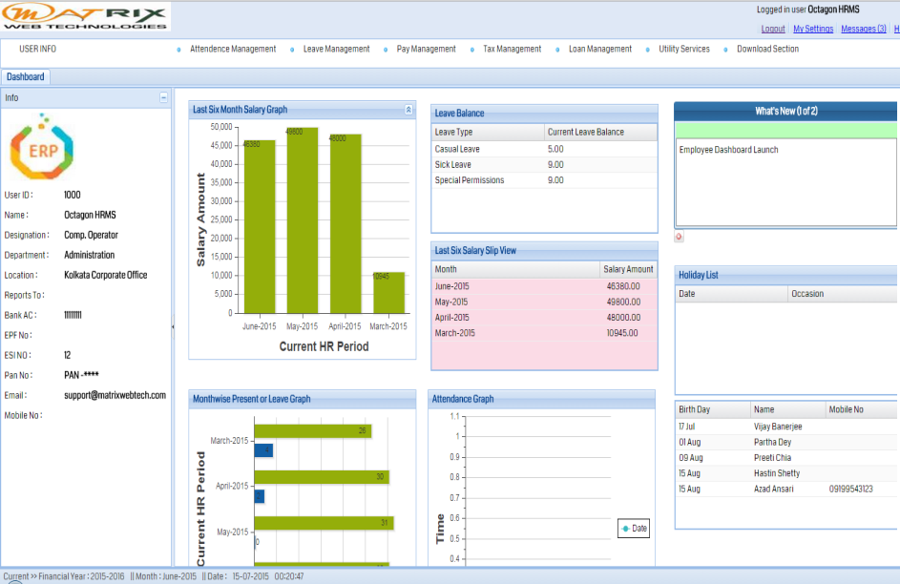The Octagon HRMS has been designed with employee self service features. Since all of our applications are Web-based, City and County employees can log in to the system with their username and password. Immediately the Web pages that they have security to access will be made available. It also offers a streamlined timekeeping interface. Timekeeping allows employees to manage tasks, record their time, and update basic personal information with no strain on HR resources.

* With Employee Dashboard and Portal Access one can view and configure information manage Information and monitor taxes through the Tax Calculator, declare your investments and keep a track of your pay slips Form 16, leave records and reimbursements.
* Joining Document Upload allows the employees to upload documents through ESS portal.
* Attendance Calendar helps employees access their attendance on a daily, weekly or monthly basis. Leave Calendar maintains a log of leaves taken by the employee. Leave applications , their approval and rejection by superiors can be seen.
* View Holiday List
* Manage Leave Application
* Personal Employee Login
* Notice Board

## Payroll Management

The biggest strength of Octagon HRMS is its flexibility and ease to user define any type of salary structure. With user defined formulas and settings we guarantee that your requirements will be perfectly implemented. All these are calculated and the pay slip for that month is generated. The required data is generated based on selection criteria. Every month, Generate employee salary on a click of a Single button. With that single click, the software accurately computes salary for all employees including Statutory Deductions (PF/PT/ESI/TDS), loan deductions, stop payments, loss of pay, pro-rata salary, Income Tax or any other defined head of pay.

* Configurable and Unlimited Salary Structure Group.
* User defined Salary Component Heads
* User defined Salary Heads (Allowance & Deductions and Others)
* All the information for bank transfers is also recorded.
* Salary Increment with Increment History
* Details of Loans and advances can be maintained.
* Loan EMI auto adjusted with salary calculation
* Maintains Payroll History for each employees
* Sick and holiday on screen accumulators
* Pro-rata Calculation
* Single Click Salary Processing
* Block Employee Salary and re-process block salary
* Income tax Calculation based on average proposed or Proof based Investment declaration
* Pay slip Generation & auto emailing and SMS to Employee
* Employee Transfer, Promotions & Increments
* Full & Final Settlement
* Generates all statutory forms such as PF, ESIC & P. Tax Report, Form 3A, Form 5,Form 12, Form 6 and Form 16 etc.
* 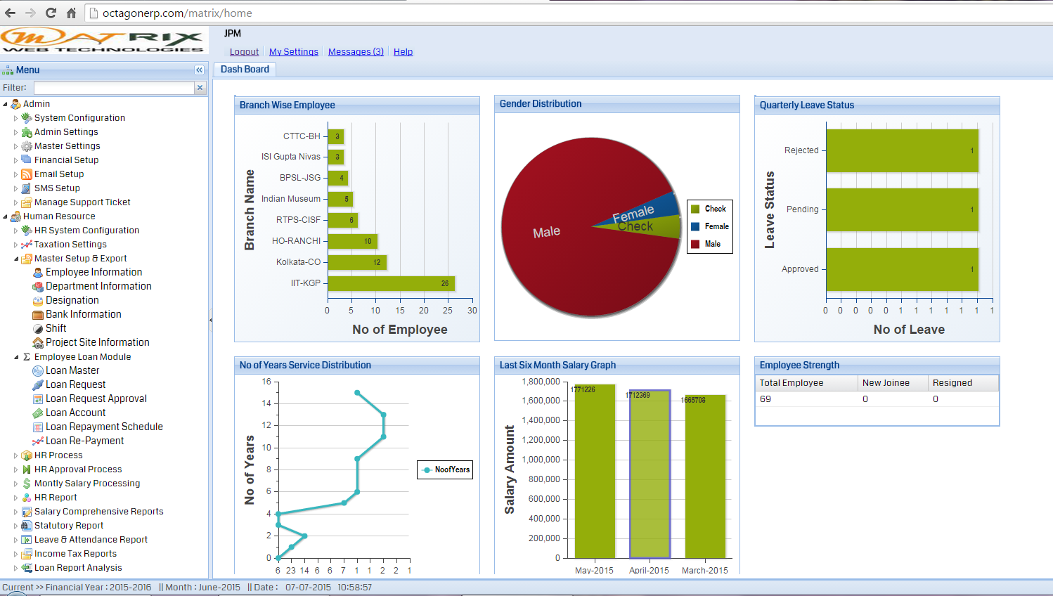A configurable journal voucher generation tool enlists necessary details after filling the company ID, financial year, payroll month, payroll year, pay heads, costs, amount of vouchers that are credited and debited, etc. It has auto integration with ERP making it easy to use.

### HR Dashboard

Octagon HRMS Dashboard business intelligence dashboard software is providing human resources departments real-time visibility into their data and greater insight into their key performance indicators (KPIs). Companies may use a dashboard to monitor human resource utilization and employee productivity. Human resources dashboards, can display metrics such as staff absenteeism, recruitment activity and payroll information. A compensation claims dashboard is commonly used to display important metrics for better data visualization. with this you can enhance employee communication, improve HR service to internal customers and enhance productivity throughout the organization.

* Exclusive HR Dashboard
* Exclusive Employee Dashboard
* Company News
* Company Events
* Birthdays
* Anniversary
* Employee Newly Joined

### Leave Management

Important Leave management system is a single leave management and attendance system that integrates these two critical HR tasks. It astutely adapts to your policy and allows employees and their managers to manage their leaves. It marks their attendance without any extra efforts from HR.

* Define Leave Type and Policy
* Highly configurable User Defined Leave Rules
* Send Leave Application online
* Employee hierarchy Leave Approval
* Track Employees on Leave
* Leave Summary and Detail Viewer

### Attendance Management

Time & Attendance module is tightly integrated with the organization’s HR data base. The in-time and out-time, lunch and breaks entered by the employees will help the respective authority in charge to keep track of the activities of the employees.

The Employee Attendance Management System helps in keeping track of the attendance of employees based on various events like shift, late, overtime, permission, holiday working and on duty.

* Multiple Attendance Class
* Flexible Attendance Input
* Late Coming, Early going, Absence due to travel on Duty
* Attendance data Integration from any Time-Machine
* Facility to Import Excel file
* Online attendance system from ESS
* ID Card Attendance Identification
* Track time who comes late
* Track time who leaves early
* Find who is present/absent
* Get worked hours report for payroll

### Loan Management

Loan module enables you to define and manage employee loan policies and their entitlement based on different parameters. Employees can request loans, which are then reviewed and approved, and converted to loan agreement which include terms of payment and the life of the loan. Loan payments are processed automatically through the payroll at the end of each pay period. It can manage advance through the same process.

* Employee Loan Request
* Loan Approval Process
* Loan Account Tracking
* Loan Adjustment
* Loan Register

### Income Tax Management

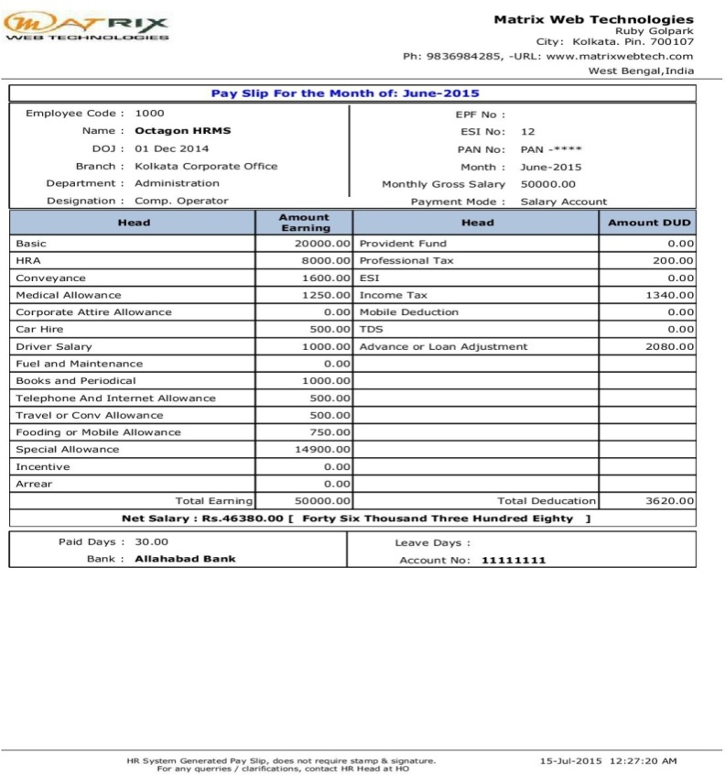Income taxes are based on an employee's wages or salary. The difference is who pays. A payroll tax is paid at least partly by the employer, while income taxes are paid by employees. Showing marital status, number of exemptions for dependents and other allowances and any additional amount an employee wants withheld. An employee does not have to have tax withheld for all dependents and can add any desired amount to the withholding. There is a federal income tax, and most states have income taxes, too.

* Auto Deducted Income tax
* Employee Investment Declaration
* Form 16 Generation

### MIS Reports

A Management Information System is a system that provides information needed to manage organizations efficiently and effectively. Further, it is regarded as a subset of the overall internal controls procedures in a business, which cover the application of people, documents and procedures used by management accountants to solve business problems such as payroll costing ,service or a business-wide strategy.

### HR Report Section

* Employee Joining Information
* Employee Profile
* Department wise Employee List
* Birthday Reminder
* Confirmation Popup
* Increment Popup
* Increment History
* Employee Card
* Employee Mail Label
* Resigned Employee Details
* Employee List

### Leave & Attendance Report

* Leave Application Sheet
* Individual Leave Account
* Leave Approval Pending
* Rejected Leave Application
* Leave Balance Sheet
* Leave Encashment History
* Holiday List
* Daily Attendance Statement
* Monthly Attendance Summary
* Current Present Employee
* Daily Absent Report
* Employee Absenteeism
* Holiday Work

### Loan Module Reports

* Monthly Loan Register
* Employee Loan Account
* Loan Repayment EMI Schedule
* Loan Approval Status
* Loan Request Statement

### Salary Reports

* Monthly Salary Sheet
* Salary Slip
* Tax Calculation Details
* Employee Salary Register
* Bank Transfer Statement
* Monthly Salary Summary
* Salary Summary Branch wise
* Salary Summary Department wise
* Salary Summary Designation wise
* Salary Comparison
* Salary Cheque Statement

### Income Tax Related Reports

* Employee PAN Status
* Employee Tax Declaration Sheet
* Tax Declaration Gap Analysis
* IT Declaration Statement
* Monthly Tax Statement
* Employee Tax Statement
* Employee Tax Calculation
* Form 16

### Statutory Report

* Professional Tax Statement
* PF Statement
* ESI Statement

# Financial Accounting

Our Finance and Accounts solution simplifies time consuming cost intensive accounting & record maintenance. It is loaded with robust features, control tools, user-friendly application design and structure. The usability features help organizations manage and finalize error free accounts as per statutory compliance

* General ledger

The company's "books" core source of information regarding the financial health of your business. The General Ledger is where you create accounts, budgets, and make journal entries.

* Chart of accounts

The chart of accounts is a listing of all accounts used in the general ledger, usually sorted in order by account number. The accounts are usually numeric, but can also be alphabetic or alphanumeric. The account numbering system is used by the accounting software to aggregate information into an entity's financial statements.

* Fully flexible fiscal period setup

A fiscal period is a budgetary accounting period. Fiscal periods can be calendar years or quarters, or any other period of time as determined by an accounting cycle. For businesses, a fiscal period is the length of time covered by company financial statements.

* Modifiable account number ranges

Assign numbers to your accounts when you set them up through the Auto Setup .You can assign account numbers yourself Choose your own numbering/lettering system.

* Recurring GL entries

Define recurring journal formulas for transactions that you repeat every accounting period, such as accruals, depreciation charges, and allocations. Your formulas can be simple or complex. Each formula can use fixed amounts and/or account balances, including standard, end-of-day, or average balances, actual or budget amounts, statistics, and period-to-date or year-to-date balances from the current period, prior period, or same period last year. You can quickly create new recurring formulas by copying and modifying existing formulas.

* Reversing GL entries

Reversing entries, or reversing journal entries, are journal entries made at the beginning of an accounting period to reverse or cancel out adjusting journal entries made at the end of the previous accounting period. This is the last step in the accounting cycle. Reversing entries are made because previous year accruals and prepayments will be paid off or used during the new year and no longer need to be recorded as liabilities and assets. These entries are optional depending on whether or not there are adjusting journal entries that need to be reversed

* Budget data in GL

Use budgeting to enter estimated account balances for a specified range of periods. You can use these estimated amounts to compare actual balances with projected results, or to control actual and anticipated expenditures.

* + Journal

A daily record of events or business; a private journal is usually referred to as a diary

* Payroll integration
* Integrated Invoicing

Perform quick invoicing by generating bills inclusive of tax and value your customers' time.

**Receivables Management**

Allows you to track your customer transactions over time and retain a history of customer charges, payments, notes, and more where the company enters money received including

* + Receipt Vouchers

Any money received from debtors against sales Invoices or on Account and for all transactions where money is received are accounted or entered using the Receipt voucher

* + User-definable receipt types

Receipts are used for the customer's accounting and also to return items to the vendor. Businesses have various options to choose from when seeking the type of receipt style to incorporate.

* + On-screen Accounts Receivable Aging

A periodic report that categorizes a company's accounts receivable according to the length of time an invoice has been outstanding. Accounts receivable aging is a critical management tool as well as an analytic tool that helps determine the financial health of a company's customers, and therefore the health of their business.

**Payables Management**

Provides everything you need to manage vendors and payments where the company enters its bills and pays money it owes including

* + Payment Vouchers

A voucher is often a pre-numbered form used in the accounts payable department to standardize and enhance a company's internal control over payments to its vendors and service providers.

* + Disbursements

The act of paying out or disbursing money. Disbursements can include money paid out to run a business, spending cash, dividend payments, and/or the amounts that a lawyer might have to pay out on a person's behalf in connection with a transaction.

* Payment Approval Process

Bills can be automatically approved for payments or go through a payment approval process so you can prioritize or delay the bill payment, select the account the bill should be paid from, and select a method of payment. Once the bill is approved for the payment you can print the check or issue an electronic payment.

* + On-screen Accounts Payable Aging

An accounting table that shows the relationship between a company’s bills and invoices and its due dates. Often created by accounting software, aging schedules can be produced for both accounts payable and accounts receivable to help a company see whether it is current on its payments to others and whether its customers are paying it on time.

* Audit trail

Accounts Payable module provides a complete audit trail of all customer transactions. After a document is released, you cannot delete or cancel the document - to correct mistakes, you must enter a correcting AP document to reverse the incorrect entry. System keeps the details of all AP Documents, including the user who entered the transaction and the user who modified the record. The auditing process is simplified by having notes as well as supporting electronic documents attached directly to the transactions.

**Multiple Company & Currency**

* Multi-Currency Accounting

Rich multi-currency and analysis capabilities optimize your international opportunities. You can maintain an unlimited number of currencies and exchange rate schedules, leveraging the ability to update exchange rates daily, and post realized and unrealized gains or losses due to currency fluctuations. Capitalize on every business opportunity by transacting in any currency.

**Banking & Reconciliation**

* Bank Reconciliation

Bank Reconciliation module matches your financial records with the bank’s list of transactions, and reconciles bank statements to actual checks and deposits.

* Cheque Management

Cheques are still the preferred payment instrument across businesses and hence easy management adds significant value in day to day operations. Hence, effective Cheque Management system is essential for any business.

Makes it easy for you to manage your cheques:

* Allows creation of multiple Cheque Books with unique ranges for every bank in Bank Ledger creation.
* Selection of cheque ranges during Voucher Entry and auto cheque numbering.
* Giving a comprehensive report of the status of all the cheques in the form of Cheque Register.
* Cheque reconciliation

At this point you will want to reconcile these cheques to see which cheques processed have cleared the bank account and which cheques remain outstanding. The Cheque Reconciliation application is where the cheques which have cleared the bank account may be reconciled. Once all the cleared cheques have been entered, a Cheque Reconciliation Report may be printed to either be forwarded to the bank or attached to the monthly statement.

**Cost & Profit Centre**

* Cost & Profit Centre

Managing the accounts and transactions allocated to different cost centers of an organization will help them to assess the profitability & potential of each segment/centres. Moreover, they can assess performance & effort in terms of investment of each department / team / set of employees / set of revenue centre.

* Customizable cost category & cost centre master helps the user perfectly map their organizational cost centre structure into the accounting system
* Ledger based cost centre allocation helps the user to manage the transaction generating time easily, as it will be specified with desired set of ledgers alone
* Cost centre-wise budgeting enables user to allocate, plan & review performance of each department
* Causal analysis reflects the reason for variance
* While recording the transactions for mapped ledgers, the application will automatically prompt for allocating to the Centres & the allocation will happen to the desired splitting
* Reports like Group wise, Ledger, etc are available to be split & view cost centre wise performance
* Reports like Category summary & its drill down feature help the user analyze the overall performance of each & every departments or centres

**Accounting Reports**

Display of information is designed to allow a user get the maximum benefit of the data that is entered. A user gets a holistic picture of the data and is also able to present information using different options. The purpose of compiling data is to present it in comprehensible accounting reports. On entering the vouchers, uses the same data and provides you with the management control reports in addition to all books and statements.

* The Cash Flow and Funds Flow display too has not been grouped under Statements of Accounts.
* Trial Balance provides you a report on the account balances sorted by groups, for all the accounts of the selected company. In other words, the Trial balance displays a collection of main groups and their closing balances.
* The Ratio Analysis Statement is a single sheet report indicating the company’s performance based on values and key indicators, over a selected period. This report gives a manager an idea of the company's financial condition and where it is going in the short-term.
* The Day Book contains all vouchers for the day, including inventory vouchers. Its purpose is to show you a day's transactions, though you can display a report for any period using Change period option.
* The List of Accounts gives the tree structure of all your masters, namely, Groups, Ledgers, Stock items, Cost Centres, Currencies, etc.
* Exception Reports are those reports that track unusual transactions or balances.

**Finance Reporting & Analysis Solutions**

Financial Analysis refers to the assessment of a business to deal with the planning, budgeting, monitoring, forecasting, and improving of all financial details within an organization. Business intelligence applications within the Financial Analysis application area include:

* Budgeting and Budget Analysis
* Financial Performance Management
* Revenue Analysis
* Cost Analysis
* Expense Analysis
* Cash Flow Analysis
* Balance Sheet Analysis
* Accounts Receivable Analysis
* Accounts Payable Analysis
* Invoicing and Billing Analysis
* 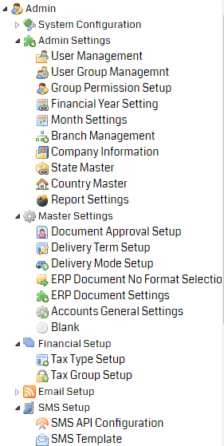Profit and Loss Statements

# Admin Management

The administration module offers users the possibility to define different levels of access to information in the application, by defining specific groups of users. The module also allows configuration of design or customization of printed documents or setting the backup actions. Administration of the application provides facilities for intervention on the general setting, on the general parameters of the application, grouped by various features, even after implementation.

* User/department levels of access to information
* Multiple information back-up solutions in the system
* Customize formats for issuing / printing of documents
* Post-deployment configuration features

## User Management

* User Group
* User Group Permission
* User Management

# Technology

|  |  |
| --- | --- |
| Web Technology | Backend Database |
|  | download (1) |

Thank You